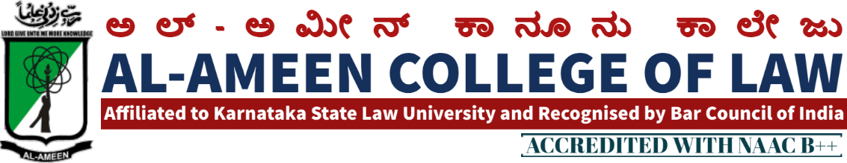
7TH MEETING OF IQAC
The 7th meeting of IQAC was held on 30th March 2016 at 2.30PM in Principal chamber. The Meeting was chaired by Dr. Mumtaz Ahmed khan, founder and Chairman AAES Bangalore and in presence of Mr. Subban Shariff, Hon. Secretary, AAES Bangalore.
QIRATH
The Meeting started with the recitation of few verses from the Holy Quran recited by Mr. Subban Shariff
WELCOME SPEECH
Prof. Waseem Khan, Principal Al – Ameen College of Law, Bangalore delivered the welcome speech.
The following points were on agenda and resolutions were passed against the same.
AGENDA | RESOLUTION
Review of the previous minutes of the meeting | Mr. Yasmeen Tabasum co-ordinator of IQAC submitted the report of the last meeting and implementation of subject resolved . Report has been submitted by the principal regarding the academics students performance in the examination and the new ideas implemented  Regular interaction with the parents has been made. Each class teacher briefed about their performance in this regard.  Industrial visit was organized to BAMUL diary circle, banargatta road, by mrs.yasmeen Tabassum on 25 th of February 2016  The moot court society organized the National Moot Court competition on 11, 12 and 13 th of march 2016, with 32 teams comprising almost 92 participants from all over India.  The co-ordinators of NSS and Legal aid cells have identified 3 villages for conducting NSS special annual camp, legal awareness and legal aid programmes scheduled tentatively on 16 , 17, and 18 of April 2016  The cultural and sports week , is being celebrated in the college from 4 th to 7 th April 2016  Guest lectures were conducted on Saturdays  Seminars and interactive session was conducted on the 8 th of march 2016 to mark the celebration of international womens day  Mr. Manohar Ranganathan human rights activist was invited for the same.  On 23 rd februvary 2016 interactive session by akhila manchia was organized on the topic “ Eco talk with law students”  On 29 th februvary 2016 seminar by ms. Emanuval Thomas, faculty of law, was organized on the topic “the changing paradigms in personal laws”
2. professional training to the law students regarding court procedures | The responsibility of organizing a occasional professional training programme for the final year students was shouldered on the sendil kumar
3. Internship in corporate firms, etc. | Al amee college of law is in the habit of conducting internship with high court judges, mediation centers, arbitration centers etc.Emphasisi was given to start corporate from internships under NGOs . Mrs. Jayalekshmi & MS bhavya was given responsibility to follow up the same.
Vote of thanks:
At the end of the meeting, voting of thanks was conveyed by mrs.yasmeen tabasuum, vice principal al- ameen college of law.

THE MEMBERS PRESENT
NO | NAME | DESIGNATION | SIGNATURE
Management Members
1 | Mr. Subban Shariff | Hon. Secretary
 | Dr. Mumtaz ahmed khan | Founder and chairman , AAES
External Members
1 | Prof. Mohan Ram | Director of Distance Education Kuvempu University
2 | Prof. G.R Bhaskar | Former Principal of BIR College of Law, Bangalore
3 | Mr. OM Prakash | Associate Prof. MS Ramaiah College of Law Bangalore
4 | Mr. Syed Munawar | Advocate, Bangalore
 | Internal Members
 | Dr. Waseem Khan M.I | Principal
 | Mrs. Yasmeen Tabassum  Co-Ordinator IQAC | Vice Principal
Staff Members
1 | Mrs. Shagutha Anjum | Lecturer
2 | Mr. Sendil Kumar | Lecturer
3 | Mrs. Jayalakshmi V | Lecturer
4 | Ms. Sahena Florence P | Lecturer
5 | Ms. Bhavya Gunashekhar | Lecturer
6 | Mr. Sheshadri | Lecturer
7 | Mr. M K Metri | Lecturer
8 | Mrs. Haseena Banu | Lecturer
Students
1 | Syed Sameer | IX se.5 years
2 | Afshan Naaz | Viii sem .5 years
3 | Sufiyan | Iv sem.5 years

PRINCIPAL

