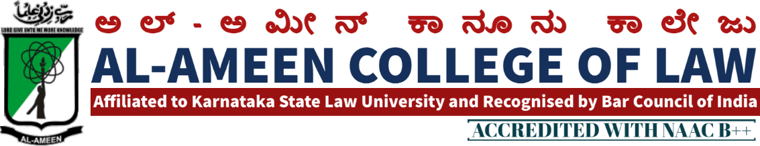
4th MEETING OF IQAC
The 3rd meeting of IQAC was conducted on 18th April 2015 at 10.00 am, in the Principal’s chamber chaired by the Hon. Secretary Mr. Subban Shariff.
AGENDA
- Qhirath
- Welcome by Principal
- Adoption of minutes of Previous meeting & report by IQAC
- Review of NAAC Criteria 1, 2, 3
- To Organize Graduation day
- Release a college magazine.
- Formulation of Alumni Association
- Review of academic performance of college
- Internship program for students
- Any other subject
AGENDA | RESOLUTION
Adoption of minutes of Previous meeting & report by IQAC | The minutes of the pervious meeting were adopted and the IQAC coordinator has submitted the report on the discussions and assignment given are accomplished
Review of NAAC Criteria 1, 2, 3 | All the criteria’s are reviewed and few suggestions were given to adopt in criteria.
To Organize Graduation day | It has been resolved to organize graduation day on 25th April 2015.
Release a college magazine. | Asst. Prof. Mrs. Shagutha Anjum has been given in charge for preparations of college magazine.
Formulation of Alumni Association | It has been decided to register Alumni Association of Al – Ameen College of Law. The in charge has been given to Vice Principal Mrs. Yasmeen Tabassum
Review of academic performance of students | Directed to conduct faculty meeting and conduct the evaluation process like organize internal tests
To organize Internship programs | Internship programs with Honorable sitting Judges of High Court of Karnataka should continue. The internship should be extended to corporate firms.

Vote of thanks:
IQAC Co-Ordinator Mrs. Yasmeen Tabassum proposed a vote of thanks.

THE MEMBERS PRESENT

NO | NAME | DESIGNATION
MANAGEMENT MEMBERS
1 | Mr. Subban Shariff | Hon. Secretary
2 | Prof. Y. Azeez Ahmed | Asst. Secretary/ Special Officer
CHAIRMAN - IQAC
1 | Mr. Waseem Khan M. I | Principal
CO - ORDINATOR
1 | Mrs. Yasmeen Tabassum | Vice principal
EXTERNAL MEMBERS
1 | Prof. G.R Bhaskar | Former Principal of BIR College of Law, Bangalore
2 | Mr. OM Prakash | Associate Prof. MS Ramaiah College of Law Bangalore
 | FACULTY | DESIGNATION
1 | Mrs. Shagutha Anjum | Lecturer
2 | Mr. Sendil Kumar | Lecturer
3 | Mrs. Jayalakshmi V | Lecturer
4 | Ms. Sahena Florence P | Lecturer
5 | Ms. Bhavya Gunashekhar | Lecturer
6 | Ms. Anusuya Jayanth | Lecturer
7 | Mr. Sheshadri | Lecturer
1 | Sheeran Mohiuddin Alavi | IX Sem 5 Years
2 | Mohammed Owais Sultan | IX Sem 5 Years
3 | Promood Kumar Patil | IV Sem 5 Years

PRINCIPAL

