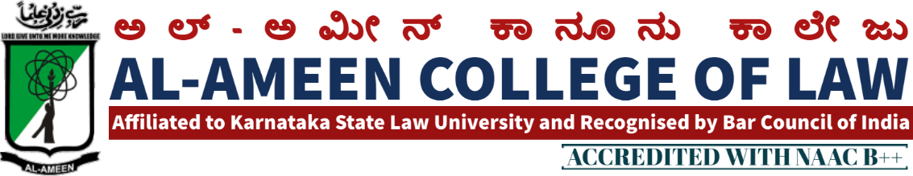
3rd MEETING OF IQAC
The 3rd meeting of IQAC was conducted on 27th September 2014 at 10.00 am, in the Principal’s Chamber. The meeting was chaired by the Hon. Secretary Mr. Subban Shariff.
AGENDA | RESOLUTION
Performance of the last meeting | Decisions and strategies adopted in the previous meeting were reviewed & discussed all the documents submitted by the coordinator in accordance with the previous meeting were verified. Projectors were installed in all the class rooms in the Seminar hall. It has been made mandatory for all the Teaching faculty to Conduct PPT classes.
Organization of SKLU Chess Competition | Al-Ameen College of Law hosted KSLU Inter-Collegiate Chess Competition and Blue selection trials successfully. The Physical Education director and the organizing Committee been congratulated and appreciated.
Improvement of Academic Performance among the Students | Conducting of Unit Test after completion of each unit is been made mandatory. It also been decided to conduct 2 preparatory examinations in every semester. Examination Committee way Constituted for the same.
Formation of Student Union | It is been decided to set-up AACL Student’s Union for various objectives. Elections Should be conducted in a democratic manner in order to select the office bearers of the Union. Responsibility is been given to Mrs. Shagultha Anjum to take-over the task.
Different committees to be formed involving students. for different events | Responsibility of forming Committees has been given to Vice- principal
Execution Strategies.  Meeting Concluded at 1.30 pm | Recommended to coordinate to initiate the above resolved subjects.

THE MEMBERS PRESENT
NO | NAME | DESIGNATION | SIGNATURE
Management Members
1 | Mr. Subban Shariff | Hon. Secretary
2 | Prof. Y. Azeez Ahmed | Asst. Secretary/ Special Officer
Chairman - IQAC
1 | Mr. Waseem Khan M. I | Principal
Co - Ordinator
1 | Mrs. Yasmeen Tabassum | Vice principal
External Members
1 | Prof. G.R Bhaskar | Former Principal of BIR College of Law, Bangalore
2 | Mr. OM Prakash | Associate Professor MS Ramaiah College of Law Bangalore
Faculty
1 | Mrs. Shagutha Anjum | Lecturer
2 | Mrs. Shabeena A.S | Lecturer
3 | Mrs. Arathy K.B | Lecturer
4 | Mrs. Jayalakshmi V | Lecturer
5 | Ms. Sahena Florence P | Lecturer
6 | Ms. Kavya Hebbar | Lecturer
7 | Mr. Athiq Ulla | Accountant
8 | Mr. Mohammed Dastagir | FDA
Students
1 | Sheeran Mohiuddin Alavi | IX Sem 5 Years
2 | Mohammed Owais Sultan | IX Sem 5 Years
3 | Promood Kumar Patil | IV Sem 5 Years
PRINCIPAL

