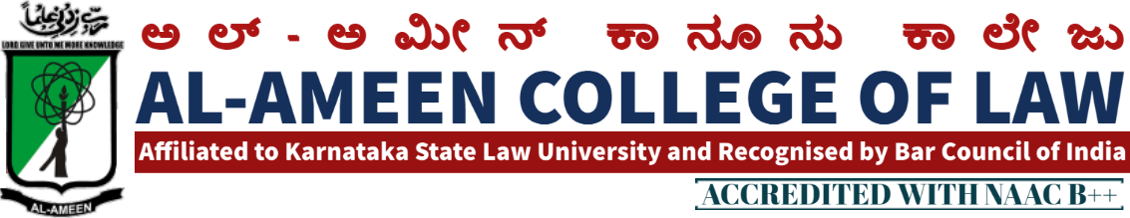
2nd MEETING OF IQAC
The 2nd meeting of IQAC was conducted on 24th February 2014 at 10.00 am, in the Principal’s Chamber. The meeting was chaired by the Hon. Secretary Janab Subban Shariff.
Agenda of the meeting and resolution
The following points were on the agenda of meeting resolutions were adopted/passed to execute/ implement each agenda.
AGENDA | RESOLUTION
Accomplishments of previous meeting | - Steps have been taken to develop quality education.  - Feedback was collected from the students.  - Principal had one to one meeting with Staff members - discussed with them about the quality enhancement as to teaching- learning process - highlighted the shortcomings and drawbacks and suggested for improvement.
Submission of SSR (self. -Study Report) by June-2015 | - It has been resolved to organize & activate the IQAC Committee to work on different criterions of NAAC wither week after this Meeting & the Same Should be Submitted (Repoll-) in next meeting & the responsibility has been given of the IQAC to co-ordinate.
Installation of projector in all the class rooms & in the Seminar Hall. | Principal is been given responsibility to get formal approval from the management for the installation of projector.
Organization of Starte Level Events | Decision taken to organize Karnataka State Law University Events for the year 2014-15 - Physical Director was given responsibility to approach the University & to coordinate the events.
Attendance Improvements | Principal was been asked to through a light on this agenda. He explained online attendance system is been introduce through an Android application where parents will get the SMS information. about the attendance & their children.
State Level Debate Competition  Meeting Concluded at 2.00 pm | - District Committee is been formed & in charge given to Mrs. Arathy KB to organize the same  - Cultural Committee is been. formed under the leadership of Mrs. Jayalakshmi v to organize the cultural feast.

MEMBERS PRESENT
NO | NAME | DESIGNATION
Management Members
1 | Mr. Subban Shariff | Hon. Secretary
2 | Prof. Y. Azeez Ahmed | Asst. Secretary/ Special Officer
Chairman
1 | Mr. Waseem Khan M. I | Principal
Coordinator
1 | Mrs. Yasmeen Tabassum | Vice principal
External Members
1 | Prof. G.R Bhaskar | Former Principal of BIR College of Law, Bangalore
2 | Mr. OM Prakash | Associate Professor MS Ramaiah College of Law Bangalore
Staff
1 | Mrs. Shagutha Anjum | Lecturer
2 | Mrs. Shabeena A.S | Lecturer
3 | Mrs. Aswathy K.B | Lecturer
4 | Mrs. Jayalakshmi V | Lecturer
5 | Ms. Sahena Florence P | Lecturer
6 | Ms. Kavya Hebbar | Lecturer
7 | Mr. Athiq Ulla | Accountant
8 | Mr. Mohammed Dastagir | FDA
Students
1 | Sheeran Mohiuddin Alavi | IX Sem 5 Years
2 | Mohammed Owais Sultan | IX Sem 5 Years
3 | Promood Kumar Patil | IV Sem 5 Years

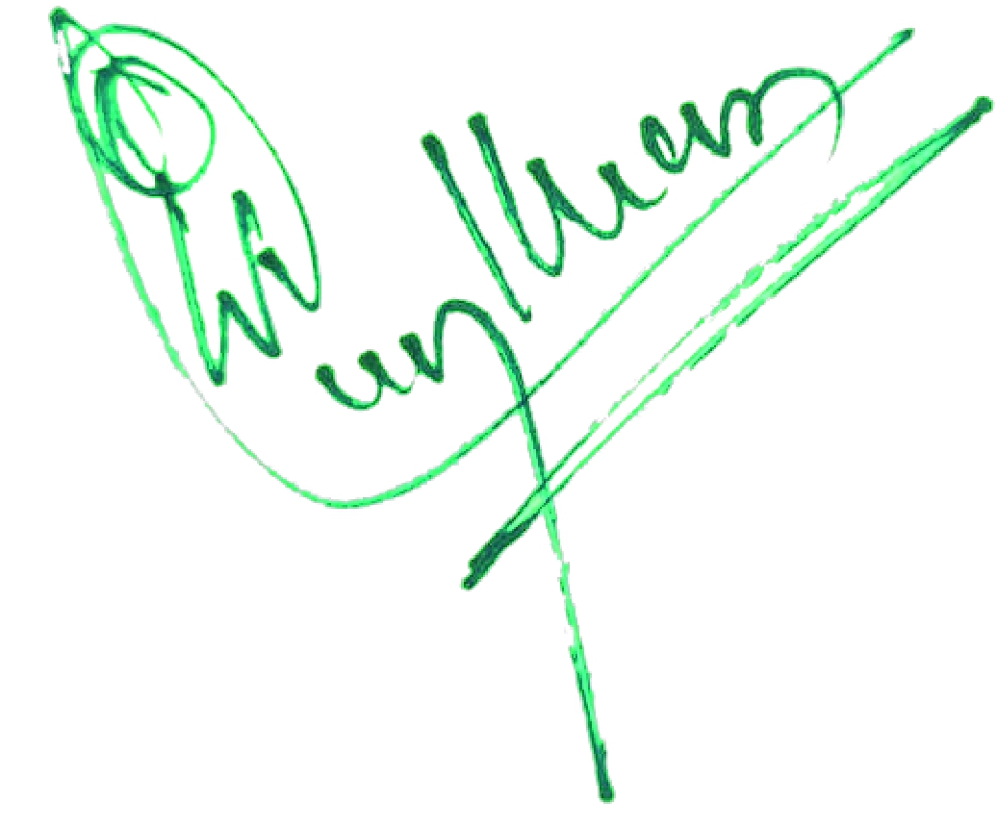
PRINCIPAL

