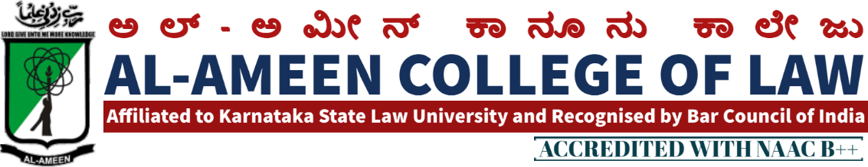
Ref. No. AACL/912/2022-23 31-12-2022

IQAC MEETING NOTICE
Notice is hereby given that the 19th Meeting of IQAC will be held on Thursday,5th January 2023 at 11 a.m., in the Principal's chamber to consider the following items of Agenda. Meeting will be presided by Mr. Umar Ismail Khan, Hon'ble Chairman, AL-Ameen Educational Society and Chief Patron, IQAC, Al-ameen College of Law. Members are requested to make it convenient to attend the same.
AGENDA:
1) Qirath,
2) Welcome speech by principal.
3) To read and confirm the minutes of last meeting
4) IQAC Report Summary 2022-23 C22-
5) Curricular and Cocurricular Activities to be conducted during the ODD semester
6) Criteria wise discussion of NAAC Accreditation.
7), Drafting of SSR for 2 Cycle.
8) Plan of action for the next semester Inauguration of Law Exhibition 2022-23
9) Consideration of suggestions given by honourable Members of the Management and External Members of the IQAC.
10) Any other matter with the permission of the chair.
11) Vote of thanks by the Vice-principal 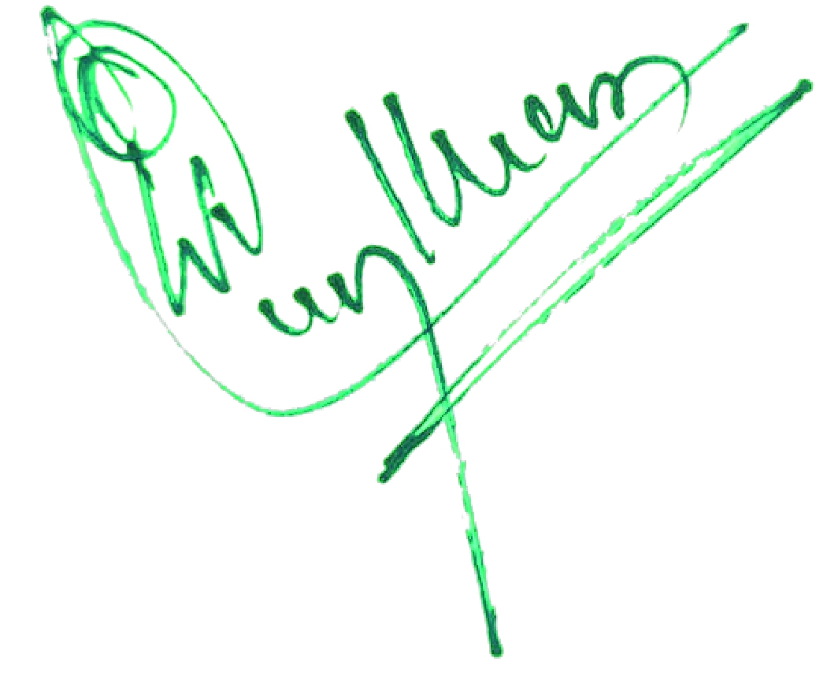
PRINCIPAL

19TH MEETING OF IQAC
The 19th Meeting of IQAC was held on 5th January 2023 at 11 am in the Principals chamber. The Meeting was chaired Mr. Umar Ismail Khan Honble Chairman. Al Ameen educational Society The Meeting started with the recitation of few verses from the Holy Quran. The same was recited by Mr Syed Suhil Asst. Professor. Dr.Waseem Khan M.1. Principal, delivered the Welcome Speech followed by breifing of purpose so objectives of the Meet.
Following Point- were on agenda & resolutions were adopted / Passed against the same.
AGENDA | RESOLUTION
proceedings of previous Meeting | proceedings of previous Meeting s were reviewed , discussed and the same were approved
IQAC Report Summary 2021- 22 | The IQAC Report Summary 2021-22 which was uploaded on NAAC postal (AGAR 2021-22) was presented by  Dr. Waseem ∙Khan M.F, Principal-  -The academic activities Conducted during the academic year such as national seminar, debate competition , webinars , graduation day celebration , farewell, constitution day celebration , sports acheivements were highlighted and the same was appreciated by the honble chairman and external members in the meeting

THE MEMBERS PRESENT
NO | NAME | DESIGNATION | SIGNATURE
Management Members
1 | Dr. umar ismail khan | Hon. chairman
2 | Dr. Zubair anwar | Hon. secretary
3 | Iqbal ahmed beig | Hon. Treasurer
Special invitee
1 | Dr. V Sudesh | Professor , Banglore university, banglore
2 | Mr. OM Prakash | Associate Prof. MS Ramaiah College of Law Bangalore
3 | Prof. anjina reddy k.r | Principal  R V institute of legal studies , bengaluru
 | Internal Members
 | Dr. Waseem Khan M.I | Principal
 | Mrs. Yasmeen Tabasum | Vice principal
 | Mr. syed Mubarak (stakeholder) | advocate
 | Jayalekshmi v | Assistant professor
Faculty Members
1 | Mrs. Hasena banu | Lecturer
2 | Mr. syed Suhail | Lecturer
3 | Mrs. Zabiulla baig | Lecturer
4 | Ms. Sahela begum | Lecturer
9 | Tabassum Ara | Librarian
Students
1 | Mohammed saad | IX se.5 years
2 | Shaffiya sheerin | Viii sem .5 years

ALUMNI
Mr. bathushah | Advocate
Mr Santhosh | advocate

PRINCIPAL

