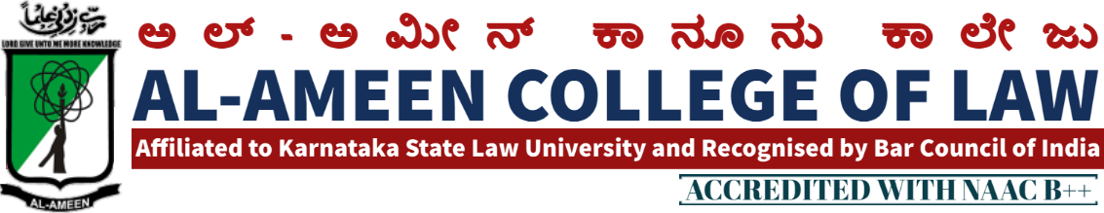

MEETING NOTICE
Meeting of members of IQAC (Internal Quality Assurance Cell) with respect to academics, Extra Curricular Activities and NAAC Re-accreditatids Cycle-2 preparations 2021-22 will be held on 28th Feb 2022 at 3.00 P.M in Principal Chamber. Meeting will be presided by Mr. Umar Ismail Khan, Honourable Chairman, Al-Ameen Educational Society and Chief Patron, IQAC Al-Ameen College of Law
We request you to kindly attend the meeting
AGENDA
1. Qirath
2. Welcome by Principal
2.1QAC report by Principal
3. Discussions on
A. Submission of SSR for Cycle-2 of NAAC accreditation 2021-22
D. Subscription of INFLIBNET to Library
E. Introduction of Certificate Course on Drafting, Pleading and Conveyance,
and Certificate Course on Comparative study on Constitutions of US, CANADA AND AUSTRALIA AND INDIA
F. Organisation of State Level FDP (Faculty Development Programme)

G. To finalise the Calendar of Events 2021-22 4. Adoption of suggestions by Honorable members from Management and External Members of the Committee.
5. Any other subject with permission of chair.
6. Vote of Thanks.
By Prof. Yasmeen Tabbassum, Vice-Principal,AACL

18TH MEETING OF IQAC
The 18 th meeting of IQAC of al Ameen college of law was held on 28 th February 2022 at 11;00 am onwardsin the principal chamber. The meeting was chaired by Mr. umar ismail khan hon’ble chairman , al ameen educational society
The meeting started with the recitation of few verses from the holy quran. The same was recited by Mr.Zeeshan alam, assistant professor.
Dr. Waseem khan, principal , delievered the welcome speech followed by briefing of purpose and objectives of the meet.
Following points were on agenda and resolutions were adopted / passed against the same QIRATH
The Meeting started with the recitation of few verses from the Holy Quran recited by Mr. Mubark khan, assistant professor

AGENDA | RESOLUTION
Accomplishment of previous meeting | Submission of AQAR is under process  Online internals were conducted through AACL Test App.  Webinar on proffessionl ethics, ADrs was conducted  Webinar on pandemic was conducted.  Graduation day was organized  Constitution day was culminated
2. submission of SSR for Cycle 2 for NAAC | AQAR for the academic year 2020-21 ,to be uploaded as early as possible . The coordinator of NAAC mrs. Yasmeen Tabasum vice principal was given responsibility of the same. The co Ordinator shall report the same to the principal and management immediately after uploading the AQAR
3. Subscription of INFLIBNET TO LIBRARY | The librarian was given responsibility to make a requisition to the management. Manangement will pass the resolution for the same. Subscription of INFLIBNET should be done with immediate effect..
4. Introduction of certificate course | Certificate course shall be introduced in comparative constitutional law, legal research methodology and in BPC . Principal have to make representation to the university in this regard.
5. Organisiing state level FDP | Approved  A state level FDP should be organized in the month of may 2022. Mr. Mubarak kahan and mr.syed Suhail were appointed as faculty coordinators for the same.
6. calender of events | The draft calender of events for the academic year 2021-2022 is hereby approved. It shall be released in an upcoming college programme.
Law review | Mrs. Jayalekshmi assistant professor was given responsibility of collecting articles to be published in Al – ameen law review . The articles may be published in the law review free of cost.
Adoption of suggestions by honourable members | nil
Any other subjects with the permission of the chair | nil
Vote of thanks:
At the end of the meeting, voting of thanks was conveyed by mrs.yasmeen tabasuum, vice principal al- ameen college of law.

THE MEMBERS PRESENT
NO | NAME | DESIGNATION | SIGNATURE
Management Members
1 | Dr. umar ismail khan | Hon. chairman
2 | Dr. Zubair anwar | Hon. secretary
3 | Iqbal ahmed beig | Hon. Treasurer
External Members
1 | Dr. anjana reddy | Principal, R.V law college
3 | Mr. OM Prakash | Associate Prof. MS Ramaiah College of Law Bangalore
 | Internal Members
 | Dr. Waseem Khan M.I | Principal
 | Mrs. Yasmeen Tabasum | Vice principal
 | Mr. syed Mubarak (stakeholder) | advocate
Faculty Members
1 | Mrs. Mubarak khan | Lecturer
2 | Mr. Abdul ashiq | Lecturer
3 | Mrs. Jayalakshmi V | Lecturer
4 | Ms. Sahela begum | Lecturer
5 | Ms. Bhavya Gunashekhar | Lecturer
6 | Mr. Sheshadri | Lecturer
7 | Mr. M K Metri | Lecturer
8 | Mrs. Haseena Banu | Lecturer
9 | Tabassum Ara | Librarian
Students
1 | malavika | IX se.5 years
2 | shivabalam | Viii sem .5 years
3 | Sufiyan | Iv sem.5 years

ALUMNI
Mr. bathushah | Advocate
Mr santhosh | advocate

PRINCIPAL

