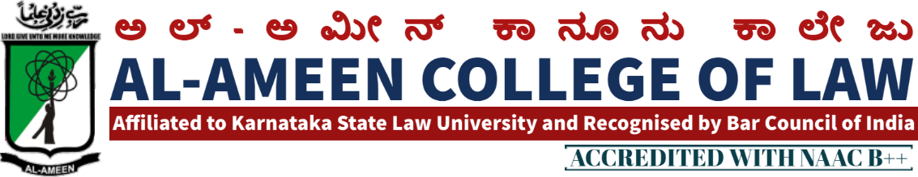
17TH MEETING OF IQAC
The 17th meeting of IQAC was held on 26 th July 2021 at 3.00 PM in college seminar hall. The meeting was chaired by Dr Subban Shariff, Hon. Secretary, AAES Bangalore.
QIRATH
The Meeting started with the recitation of few verses from the Holy Quran recited by Mr. Mubark khan, assistant professor
WELCOME SPEECH
Prof. Waseem Khan, Principal Al – Ameen College of Law, Bangalore delivered the welcome speech.
The following points were on agenda and resolutions were passed against the same.
AGENDA | RESOLUTION
Accomplishment of previous meeting  - AGENDA  Submission and uploading of AQAR | The previous meeting agenda was reviewed , the principal briefed summarily about activities conducted in the college during the academic year.  Webinars, law day celebrations , graduation day, and other activities were highlighted by the principal.  The coordinator of IQAR was instructed regarding uploading of AQAR 2020 on the portal before the last date.
2. Uploading and submission SSR | The co-ordinator of IQAR was enquired about the drafting of criterias of SSR, nd duration taken by the co-ordinators of different criterias of SSR , for uploading the same on HEI portal
3. Online internal exams | The exam committee was instructed to conduct online internals by way of MCQ due to the prevailing pendos.
4. Activities | Webinars, on different subject like ADRS, professional ethics, cyber laws, medico negligence etc.  Graduation day, for the outgoing students was instructed to be conducted by the co-ordinators in the month of June.  Constitution day celebration the legal cell of college in of adoption of constitution by the country the cell was directed to organize law day celebration , as also tradition of the college  Online quiz, moot court society was directed by the committee to conduct online quiz
Vote of thanks:
At the end of the meeting, voting of thanks was conveyed by mrs.yasmeen tabasuum, vice principal al- ameen college of law.

THE MEMBERS PRESENT
NO | NAME | DESIGNATION | SIGNATURE
Management Members
1 | Mr. Subban Shariff | Hon. Secretary
 | Dr. B.H Zakir | Assistant secretary
External Members
1 | Dr. anjana reddy | Principal, R.V law college
3 | Mr. OM Prakash | Associate Prof. MS Ramaiah College of Law Bangalore
 | Internal Members
 | Dr. Waseem Khan M.I | Principal
Faculty Members
1 | Mrs. Shagutha Anjum | Lecturer
2 | Mr. Mubarak khan | Lecturer
3 | Mrs. Jayalakshmi V | Lecturer
4 | Ms. Sahela begum | Lecturer
5 | Ms. Bhavya Gunashekhar | Lecturer
6 | Mr. Sheshadri | Lecturer
7 | Mr. M K Metri | Lecturer
8 | Mrs. Haseena Banu | Lecturer
Students
1 | Syed Sameer | IX se.5 years
2 | Afshan Naaz | Viii sem .5 years
3 | Sufiyan | Iv sem.5 years

PRINCIPAL

