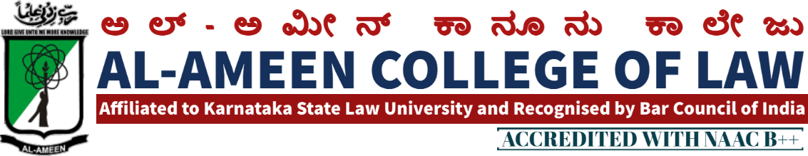
13th MEETING OF IQAC
The 13th meeting of IQAC of the Al-Ameen College of Law was held on 4th March 2019 at 2.30 pm onwards in the Principal’s chamber. The meeting was chaired by Dr. Subban Shariff, the Hon. Secretary AAES.
QIRATH:
The Meeting commenced with recitation of Qirath – E – Quran recited by Mr. Abdul Ashik, Faculty of Law, AACL.
WELCOME SPEECH:
Dr. Waseem Khan M.I, Principal AACL got the opportunity to welcome all the attendees of the meeting.
AGENDA | RESOLUTION
Accomplishments of the previous meeting | Academic calendar was reviewed. Academic committee presented the report as to activities implemented. The report was analyzed. It was further recommended to complete the remaining academic activities with due responsibility.  Online feedback system was implemented through a college mobile app and also through the college website.  The Disciplinary Committee presented its report as to moral responsibilities created amongst the students, compulsory uniform, anti-ragging etc.
Library Books | It was recommended to update the library stock, reference books, journals and student edition books in each subject.
National Level Programmes | It has been resolved to organize National seminar, state level debate competition. The responsibility was assigned to Mrs. Yasmeen Tabassum and Mrs. Jayalakshmi V.
Research projects | The Research Committee comprising of Mrs. Sahana Florence, Mr. Mubarak khan and Mr. Abdul Ashik was constituted to undertake major/minor research projects and report the same in the next meet.
Any other subject | It has been resolved to conduct a parent meeting. The class teachers were given responsibility to conduct the same.
Vote of Thanks:
By Mrs. Yasmeen Tabassum, Co-Ordinator, IQAC
The meeting was closed at 4.00 pm
MEMBERS PRESENT IN THE 13TH MEETING
NO | NAME | DESIGNATION | SIGNATURE
Management Members
1 | Mr. Subban Shariff | Hon. Secretary
Stake Holders
1 | Prof. Mohan Ram | Director of Distance Education Kuvempu University
2 | Prof. G.R Bhaskar | Former Principal of Balaji College of Law, Bangalore
3 | Mr. OM Prakash | Associate Professor MS Ramaiah College of Law Bangalore
Internal Members
1 | Dr. Waseem Khan M. I. | Principal
2 | Mrs. Yasmeen Tabassum  Co-Ordinator IQAC | Vice Principal
Faculty Members
1 | Mrs. Jayalakshmi V | Asst. Prof.
2 | Ms. Sahana Florence | Asst. Prof.
3 | Mr. Mubarak Khan | Asst. Prof.
4 | Mr. Abdul Ashik | Asst. Prof.
5 | Mrs. Afshan Noor | Asst. Prof.
6 | Ms. Ayesha Kausar | Asst. Prof.
7 | Mrs. Haseena Banu | Asst. Prof.
8 | Mr. Zabiullah Baig | Physical Edu. Director
9 | Ms. Tabassum Ara | Librarian

PRINCIPAL

