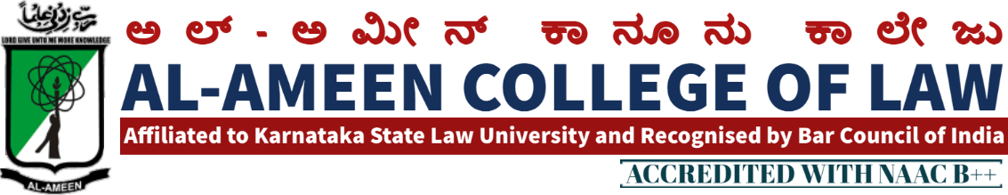
12th MEETING OF IQAC
The 12th meeting of IQAC of the Al-Ameen College of Law was held on 30th July 2018 at 3.30 pm, in the Principal’s chamber chaired by Dr. Subban Shariff, AAES.
The Meeting commenced with recitation of few versus from the Holy Quran recited Mr. Mubarak Khan, Faculty of Law.
Dr. Waseem Khan M.I, Principal delivered the welcome speech.
AGENDA | RESOLUTION
Review of previous minutes of meeting | The overall academic plan & progress was Reviewed. A Result-analysis system was formed to analyse the previous year results.  Academic Committee presented the report as to innovative methods adopted by the faulty members:  - PPT Presentation.  - Question Answer Session  - Unit Test at end of each unit etc.  Research was carried out by the research Committee in collaboration with an NGO pertaining to Child Labor issues and challenges.  The research report was submitted to labour Commission, Ministry of Labour & Employment Govt. of Karnataka.
Academic calendar | Academic calendar for the next academic year was discussed.
Feedback Systems | The existing students, alumni students and parents feedback system was discussed. It was decided to take feedback from all the students through online mode via the college website.
Guidelines for Faculty | New modified guidelines for faculty members as to personality, uniformity, academics, curricular & extracurricular/co-curricular activities were explained and asked to be adopted.
Any other matter | The Disciplinary committee was asked to submit a report as to any committed issues and any actions taken by them
Ms. Sahana Florance and Mrs. Yasmeen Tabassum conveyed vote of thanks at the end of the meeting. The meeting concluded at 4.30 pm.
MEMBERS PRESENT
NO | NAME | DESIGNATION | SIGNATURE
Management Members
1 | Mr. Subban Shariff | Hon. Secretary
External Members
1 | Prof. Mohan Ram | Academician
2 | Prof. G.R Bhaskar | Former Principal
3 | Mr. OM Prakash | Faculty of Law
4 | Mr. Syed Munawar | Advocate, Bangalore
Internal Members
1 | Dr. Waseem Khan M.I | Principal
2 | Mrs. Yasmeen Tabassum  Co-Ordinator IQAC | Vice Principal
Faculty Members
1 | Mr. Sendil Kumar | Asst. Professor
2 | Mrs. Jayalakshmi V | Asst. Professor
 | Ms. Sahena Florance | Asst. Professor
3 | Ms. Bhavya Gunashekhar | Asst. Professor
4 | Mrs. Haseena Banu | Asst. Professor
5 | Ms. Sana Kawsir | Asst. Professor
6 | Ms. Tasfiya | Asst. Professor
7 | Mr. Mubarak Khan | Asst. Professor
8 | Mr. Abdul Ashik | Asst. Professor

PRINCIPAL

