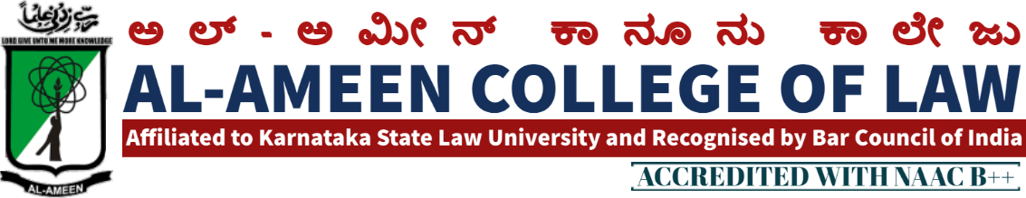

15 th MEETING OF IQAC MEETING

The 15th Meeting of IQAC of Al Ameen College of Law was held on 22nd September 2020 at 2:00 pm in the principal's Chamber. In the principal's chamber, chaired by Mr. Subhan sheriff, hon. Secretary Mr. Subhan sheriff AAES
QIRATH
The meeting commenced with the recitation of few verses from the Holy Quran, recited by Mr. Mubarak khan , faculty of law Banglore
WELCOME
Welcome speech was delivered by prof. Waseem khan M.I principal, Al ameen college of law.
SI NO. | AGENDA | RESOLUTION
1 | Accomplishment of previous meeting | Minutes of the 14 th meeting was reviewed , principal Mr. Waseem Khan M.I briefed about the overall academic plan for the offline classes , also the steps taken for the collection of feedback of facilities and principal submitted the report of the same.  IQAC report was submitted and also different activities were been planned for being executed in the academic year.  SSR committee was constructed for drafting of the SSR to be submitted for NAAC  Academic calendar was prepared and guidelines were briefed to work and the various tasks  Internals for both the cases was conducted as per the university guidelines. The subject particulars, the subject teachers were instructed to conduct and give the students guidelines as per the university.  The research committee , activities have inrealeted for research as per the decided topic in the earlier meeting
2 | Inauguration academics and graduation day | As per the calendar of events of the academic year . it was instructed for organising a programme for inaugurating the academic year and also a graduation and a send for the final year students of both the courses, and the same to be reported in the next meeting of the programme. Some was assigned to mr. Mubarak khan
3 | .  Orientation Day | Mr. Abdul m rawather faculty was assigned to conduct the orientation programme online/offline.  Also freshers day after the programme was instructed to be conducted the freshers. Day work was assigned to another faculty ie, mrs. Jayalekshmi and ms. Ayesha kanser
4 | IQAC report 2019 submission | Mrs. Yasmeen tabasum the IQAC co- Ordinator was about the changes in submisiion IQAC report through IQAC , the co- Ordinator was also directed to submit as per the changing norms and guidelines of NAAC 2019

VOTE OF THANKS
A vote of thanks was given by Mrs. Yasmeen Tabassum IQAC, co-ordinator. The meeting concluded at 5.30 pm
ATTENDEES OF THE MEETING PRESENT

MANAGEMENT MEMBERS PRESENT
NAME | DESIGNATION
Dr. Subhan sheriff | Hon. secretary

INTERNAL MEMBERS
Prof .Waseem Khan M.I | Principal  AACL

EXTERNAL MEMBERS
Prof.mohan ram | Academician
Prof bharkarmr.  Om prakashmr. | Ex. Principal Balaji law college, banglore  Assistant professor MSR law college banglore

FACULTY MEMBERS
Mrs jayalekshmi v | Assistant professor
Mrs bhavya gunashekar | Assistant professor
Mr. sendil kumar | Assistant professor
Mrs hasena banu | Assistant professor
Mr. M.K metri | Assistant professor
Mrs. Prathiba radha krishnann | Assistant professor
Mr. prathiba radha krishnan | Assistant professor
Mr Jayanth.s | Assistant professor

STUDENTS MEMBERS
Ms.nousheen | student
Ojei Chibuzor | student
Ms. Aarshiya | student

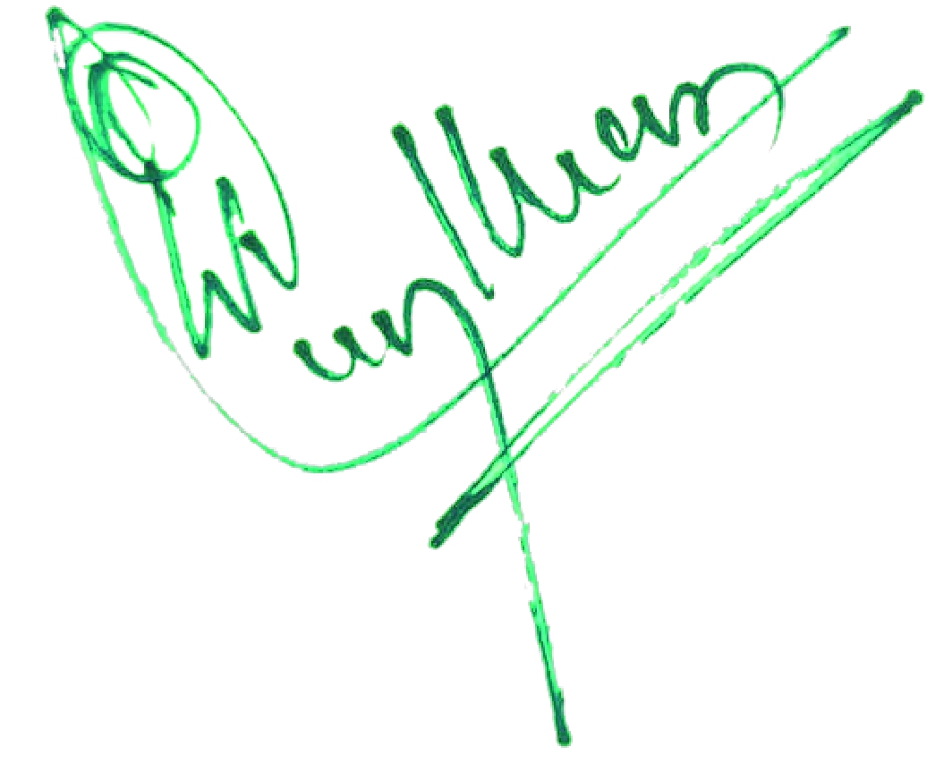 PRINCIPAL

