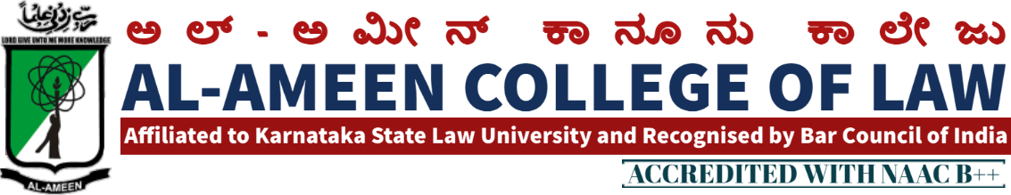

15 th MEETING OF IQAC MEETING

The 15th Meeting of IQAC of Al Ameen College of Law was held on 22nd September 2020 at 2:00 pm in the principal's Chamber. In the principal's chamber, chaired by Mr. Subhan sheriff, hon. Secretary Mr. Subhan sheriff AAES
QIRATH
The meeting commenced with the recitation of few verses from the Holy Quran, recited by Mr. Mubarak khan, faculty of law Banglore
WELCOME SPEECH
Welcome speech was delivered by prof. Waseem khan M.I principal, Al ameen college of law.
SI NO. | AGENDA | RESOLUTION
1  2 | Minutes of the last meeting  Academics | Minutes of the last meeting were reviewed as to check how far the same got implemented. 500 new books, 200 journels arrived and the same were kept in library. 1000 new text book have been already ordered and yet to be recievied . new subscription for journel have been made  Inter-class Moot Court Competition & Law quiz Competitions were organized  The Reseach Committee received on à proposed from an NGO as to draft a Model Bill on Mob Lynching. Accordingly the Research Committee drafted a Model Bill Title "Mob Lynching (prevention, prohibition, Redressal & Compensation in to victims) Bill. The same was submitted to NGO & NGO has forwarded the same to the Law Minister, Ministry off Law & Justice, Govt of India  Along with the plan progression of academies, feed back & Facility from Students & parents was to be adopted and the report should be produced against the same In the next meeting
3 | NAAC Accreditation Cycle 2 | As College is undergoing 2nd Circle of NAAC Accreditation IQAC cell was recommended to become more active. Different Criterios were allotted to different frontiers for the preparation of self | Study Report (SSR)
4 | .  Academic Calendar | Academic Calendar was designed for the academic year.
5 | Evaluation / Assessment | Internals (Internal Assesment) has to be made in accordance with the University guidelines. All the Subject teachers were recommended to adopt time-bound actions for the same by giving the students research oriented topics Judgement analysis etc. The practicals must also be conducted as per the University guidelines only.
6 | Research | The Research Panel was constituted to undertake Research projects related to socio-legal aspects. It  Was Suggested to undertake research on Adverse Impact of Nationwide lockdown on quality education .it was also suggested to undertake surveys

VOTE OF THANKS
Ms. Sahana Florence assistant professor proposed the vote of thanks and the meeting was concluded at 5.15 pm
ATTENDEES OF THE MEETING PRESENT

MANAGEMENT MEMBERS PRESENT
NAME | DESIGNATION
Dr. Subhan sheriff | Hon. secretary

INTERNAL MEMBERS
Prof .Waseem Khan M.I | Principal  AACL
Mrs. Yasmeen tabasum | Vice principal , AACL

EXTERNAL MEMBERS
Prof.mohan ram | Academician
Prof bharkarmr.  Om prakashmr. | Ex. Principal Balaji law college, banglore  Assistant professor MSR law college banglore

FACULTY MEMBERS
Mrs jayalakshmi v | Assistant professor
Mrs bhavya gunashekar | Assistant professor
Mr. sendil kumar | Assistant professor
Mrs hasena banu | Assistant professor
Mr. M.K metri | Assistant professor
Mrs. Prathiba radha krishnann | Assistant professor
Mr. prathiba radha krishnan | Assistant professor
Mr Jayanth.s | Assistant professor
STUDENTS MEMBERS
Ms.nousheen | student
Ojei Chibuzor | student
Ms. Aarshiya | student

PRINCIPAL

