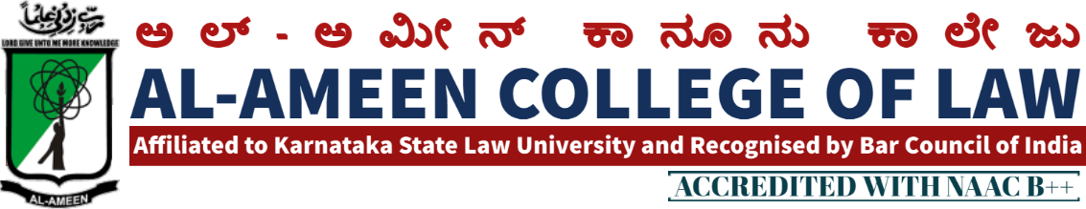

10th MEETING OF IQAC MEETING

The 10th Meeting of IQAC of Al Ameen College of Law was held on 15th July 2017 at 3:00 pm in the principal's Chamber. In the principal's chamber, chaired by Mr. Subhan sheriff, hon. Secretary Mr. Subhan sheriff AAES
QIRATH
The meeting commenced with the recitation of few verses from the Holy Quran, recited by Mr. Syed Munawar, Advocate, Banglore
WELCOME SPEECH
Welcome speech was delivered by prof. Waseem khan M.I principal, Al ameen college of law.
SI NO. | AGENDA | RESOLUTION
1 | consideration of meeting minutes | Mr. Waseem Khan MI principal, briefed about- the overall academic  performance of the college.  Various Committees Submitted their reports pertaining to their assigned work.  * An Interactive Session  Was organized on 5th May 2017 on Environmental protection Mr. Akhil Environmental Activist was the Resource person
2 | .  Organization of National Moot Court Competition | It was decided to organize II Moot Court Competition on huge level the Coordination of the the Same was assigned to  i. Sahana Florence Asst-professor  ii. Ms. Bharya Ganashuker- assistant professor
3 | NSS + Legal Aid | It is been resolved to · organize Special Annual Camp of NSS & Legal Aid- Legal Awareness programme
4 | Cultural & Sports | . It was decided to organize cultural and sports events . the responsibility of the same was shouldered on  Mrs. Jayalekshmi v& mr. sheshadarik & mr. sendil kumar will also be there
5 | Graduation Bay  . | MS. Solana Florence was assigned the tasks of organizing Graduation Day
6 | Other subjects | Other matters in connection with academic excellence were discussed

VOTE OF THANKS
Ms. Sahana Florence assistant professor proposed the vote of thanks and the meeting was concluded at 5.15 pm
ATTENDEES OF THE MEETING PRESENT
MANAGEMENT MEMBERS PRESENT
NAME | DESIGNATION | SIGNATURE
Dr. Subhan sheriff | Hon. secretary
Dr. Mumtaz ahmed khan | Founder and chairman

INTERNAL COMMITTEE MEMBERS
Prof .Waseem Khan M.I | Principal  AACL
Ms. Sahana florance p | Assistant professor  AACL

EXTERNAL MEMBERS
Prof.mohan ram | Academician
Prof bharkarmr.  Om prakashmr.syed munawar | Ex. Principal Balaji law college, banglore  Assistant professor Ramaiah college banglore
Mr syed Munawar s.j | Advocate, bangalore

FACULTY MEMBERS
Mrs jayalekshmi v | Assistant professor
Mrs bhavya gunashekar | Assistant professor
Mr. sendil kumar | Assistant professor
Mrs hasena banu | Assistant professor
Mr. M.K metri | Assistant professor
Mrs. Prathiba radha krishnann | Assistant professor
Mr. prathiba radha krishnan | Assistant professor
Mr Jayanth.s | Assistant professor

STUDENTS MEMBERS
Ms.nousheen | student
Ojei Chibuzor | student
Ms. Aarshiya | student

PRINCIPAL

